**Theory Assignment – 2**

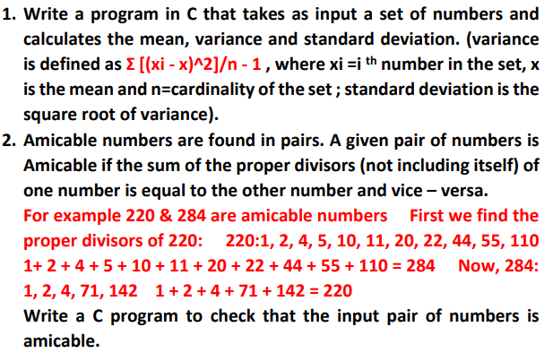#include <stdio.h>

#include <math.h>

int main(){

    int n; *// Number of elements*

    int xi; *// current element*

    float x = 0.0; *// Mean*

    float variance; *// Variance*

    float sd; *// Standard Deviation*

    float sum = 0.0; *// Temp Variable*

    printf("Number of elements to be entered : ");

    scanf("%d", &n);

    int arr1[n];

    for (int i = 0; i < n; i++)

    {

        printf("Enter number : ");

        scanf("%d", &arr1[i]);

        xi = arr1[i];

        x = x+xi;

    }

    x = x/n; *// Mean Calculated*

    for (int i = 0; i < n; i++)

    {

        xi = arr1[i];

        sum += pow(xi-x,2);

    }

    variance = sum/(n-1); *// Variance Calculated*

    sd = pow(variance, 0.5); *// Standard Deviation Calculated*

    printf("\nMean = %f\nVariance = %f\nStandard Deviation = %f", x, variance, sd);

    return 0;

}

Output :-

Number of elements to be entered : 5

Enter number : 1

Enter number : 2

Enter number : 3

Enter number : 4

Enter number : 5

Mean = 3.000000

Variance = 2.500000

Standard Deviation = 1.581139

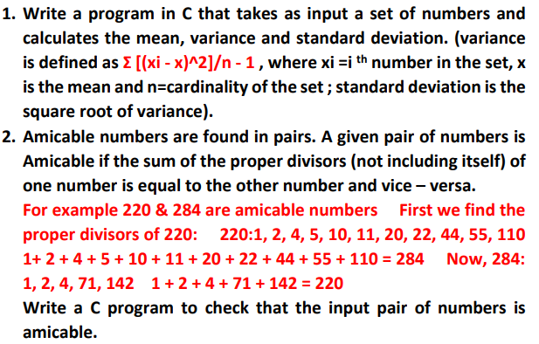#include <stdio.h>

int main(){

    int num1, num2;

    int sum1=0, sum2=0;

    printf("Enter two numbers : ");

    scanf("%d %d", &num1, &num2);

    for (int i = 1; i < num1; i++)

    {

        if(num1%i==0){

            sum1+=i;

        }

    }

    for (int i = 1; i < num2; i++)

    {

        if(num2%i==0){

            sum2+=i;

        }

    }

    if(num1 == sum2 && num2 == sum1){

        printf("\nBoth the numbers are amicable numbers.\n");

    }

    else{

        printf("\nNo, both the numbers are not amicable numbers.\n");

    }

    return 0;

}

Output :-

Enter two numbers : 220 284

Both the numbers are amicable numbers.

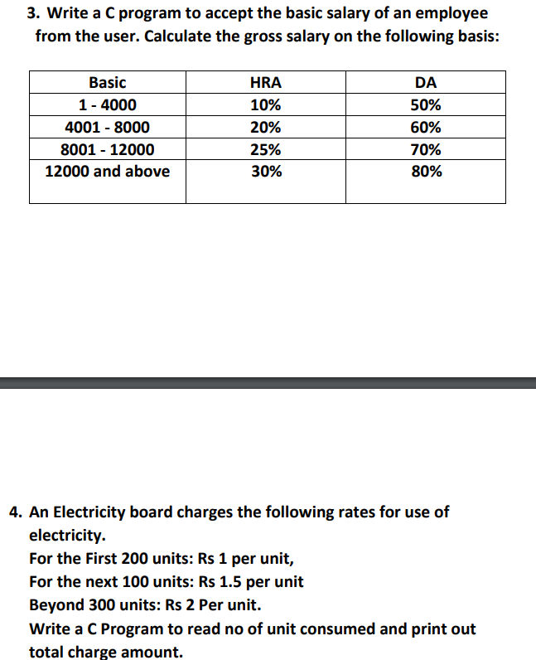#include <stdio.h>

int main(){

    int basicSalary;

    printf("Enter basic salary : ");

    scanf("%d", &basicSalary);

    float hra, da;

    if(basicSalary>=1 && basicSalary<=4000){

        hra = basicSalary*0.1;

        da = basicSalary*0.5;

    }

    else if(basicSalary>=4001 && basicSalary<=8000){

        hra = basicSalary*0.2;

        da = basicSalary*0.60;

    }

    else if(basicSalary>=8001 && basicSalary<=12000){

        hra = basicSalary*0.25;

        da = basicSalary*0.70;

    }

    else if(basicSalary>12000){

        hra = basicSalary*0.3;

        da = basicSalary*0.80;

    }

    printf("Gross salary = %.2f", basicSalary+hra+da);

    return 0;

}

Output :-

Enter basic salary : 5000

Gross salary = 9000.00

#include <stdio.h>

int main(){

    float sumAmount = 0;

    int unit = 0, unitCopy;

    int unitIncreased = 0;

    printf("\nEnter unit of electricity used : ");

    scanf("%d", &unit);

    unitCopy = unit;

    if(unit > 300){

        unitIncreased = unit-300;

        sumAmount += unitIncreased*2;

        unit = unit-unitIncreased;

    }

    if(unit>=201 && unit <= 300){

        unitIncreased = unit-200;

        sumAmount += unitIncreased*1.5;

        unit = unit-unitIncreased;

    }

    if(unit<=200){

        sumAmount += unit*1;

    }

    printf("\nTotal Unit : %d\nTotal bill amount = %.2f", unitCopy, sumAmount);

    return 0;

}

Output :-

Enter unit of electricity used : 304

Total Unit : 304

Total bill amount = 358.00

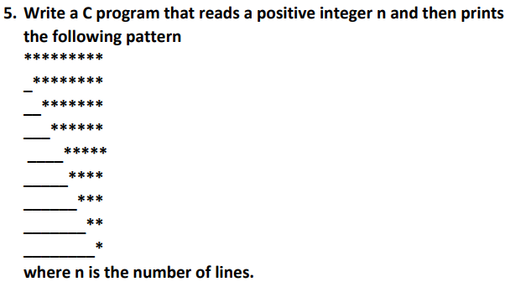#include <stdio.h>

int main(){

    int n = 9;

    for (int i = 0; i < n; i++)

    {

        for (int j = 0; j < i; j++)

        {

            printf("  ");

        }

        for (int k = 0; k < n-i; k++)

        {

            printf("* ");

        }

        printf("\n");

        printf("\n");

    }

    return 0;

}

Output :-

* * * * * * * * *

* * * * * * * *

* * * * * * *

* * * * * *

* * * * *

* * * *

* * *

* *

*